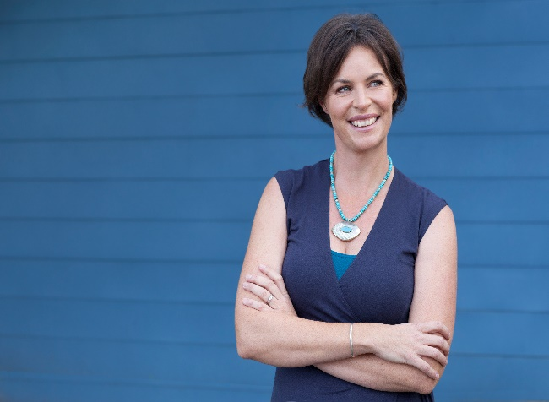
Dr Sarah MaKay
Workshop Title:-
All In Her Head? Lessons learned writing two books on the female brain.
Dr Sarah McKay is an Oxford-educated neuroscientist, science communicator, and author of The Women's Brain Book. The Neuroscience of Health, Hormones and Happiness and Baby Brain: The surprising neuroscience of how pregnancy and motherhood sculpt our brains and change our minds (for the better)
In her talk, Dr McKay will discuss what happens inside women's brains as we move through the phases of life and the unique - and often misunderstood - effects of female biology and hormones and how they interact with culture to shape the brain.
For decades, women’s minds and brains were largely ignored as niche or irrelevant unless something went badly wrong (and it was then often dismissed as hysteria!). Thankfully, a new generation of scientists working in neuroscience, women’s health, development and ageing are showing us the resilience and potential of brains that have traversed puberty, pregnancy, parenthood and peri-menopause.
BIO:
Dr Sarah McKay is a neuroscientist and science communicator who specialises in translating brain science research into simple, usable strategies for health and well-being.
Sarah grew up in New Zealand and completed her BSc (Hons) in Neuroscience at Otago University, then headed to Oxford University to complete an MSc and DPhil in neuroscience. She sums up her thesis with the words, 'Nature, Nurture or Neuroplasticity'. After five years of postdoctoral research in spinal cord injury, Sarah hung up her lab coat to pursue a career in science communications.
Sarah is the founder and director of Think Brain, which offers a global audience online professional development programs in applied neuroscience and women’s brain health.
Sarah calls Sydney's Northern Beaches home, and with her Irish husband, they're raising two surfer dudes and one cocker spaniel.

