The Interplay between Neuroscience and Chronic Pain – a personal journey
One in five people under 60 years of age live with chronic pain and many feel misunderstood and unsupported. Dr Dawn Macintyre was one of those people and in today's session you will experience her journey from living a full life to a life so diminished, full of pain, shame, and exhaustion that she was desperate enough to want to take her own life.
Chronic pain is a complex condition. It involves changes in the nervous system, cognitive processing, and the emotional / memory regions of the brain as well as changes in the function of neurotransmitters such as glutamate and GABA.
Neuropsychotherapist, Jan Sky will join Dawn in unpacking her story where she will share insights into the psychosocial challenges people living with chronic pain face, and strategies to help de-stigmatise non-disease related chronic pain.
This workshop will take you on a journey with Dawn, starting at ten days old through to the five years of totally debilitating pain, and thankfully, out the other end. After the workshop you will be better positioned to understand the multidimensional aspects of chronic pain and how you can best support your clients or loved ones to live their best life
Leaning outcomes will include:
- Why Dawn’s story is important and what she sees as progress and the gaps.
- Understanding the neuroscience of chronic pain and why we need a multilevel approach to supporting clients.
- Strategies to help to de-stigmatise non-disease related chronic pain.
- Understanding of key issues around chronic pain / chronic conditions.
- Counsellor risks such as understanding complexities of living, validation, uniqueness of individual situations and language.
- Impact on relationships, financial situations, and social connections.
- Challenging your professional and/or personal approach to people living and/or caring for people with chronic pain.

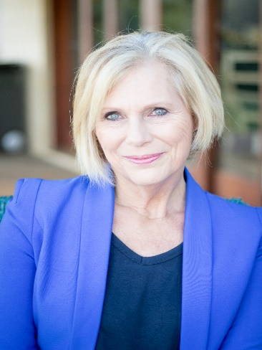
Dawn Macintyre PhD; MPH; BH (hons) Education and Psychology; MACA (clinical)
Dawn considers herself fortunate to be a parent, grandparent and one who has fostered many children over the years. She has had a diverse career including a clinical counselling and supervision practice spanning 30 years, publications in public health peer reviewed journals, two chapters in public health books and contributed papers to the WHO suicide prevention plans. Dawn’s career also involved her establishing a World Health Organisation Safe Communities program at the Mater Children’s hospital, co-hosting DV workshops, managing a pilot program to establish an early intervention anxiety and depression program for hard-to-reach communities, and as a volunteer, supporting families who had family members incarcerated overseas.
Later in her career, Dawn took on the challenge of a doctorate, identifying gaps in support across the health, social and community sectors regarding stigmatised grief and child death.
Dawn is also author of 6 books, 4 children’s books and two counselling related books. ‘Nothing Changes if Nothing Changes – a practical guide to choosing the right counsellor’ was self-published in 2008 and in 2020 Dawn was thrilled to have a publisher accept a book about her personal journey, ‘Living with Chronic Pain – From OK to Despair and Finding my Way Back Again’.
Following the positive response to her book, Dawn is now pursuing her next project, developing workshops and online training for people living and working with chronic pain.
www.drdawnmacintyre.com

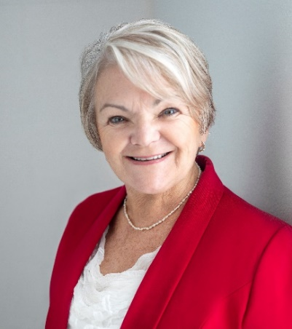
Jan Sky Grad Cert Applied Neuroscience, Grad Cert Health Sciences, Diploma Counselling Skills, Diploma of Clinical Hypnotherapy
Jan Sky is a graduate of Neuroscience who uses applied brain capacity techniques in therapy to bring about understanding and desired changes to behaviours.
Originally from Sydney and now residing on the Gold Coast, she enjoys a more relaxed lifestyle in both business and social. Jan is a proud grandmother of the most beautiful grandson ‘ever’ and passionate about life and living it to her fullest capacity. Jan has worked in clinical practice for over 25 years and with a business background recently developed ‘Brain Potential, leadership powered by neuroscience’. This program assists leaders at all levels to understand brain function in relation to behaviour and make personal changes where necessary while supporting others to be their very best.
Jan is recognised internationally for her work in Brain Potential and change and for creating the ESI (Executive State Identification) Mapping tool that maps the social neural network of the brain. Using ESI and hypnotherapy works as an amazing combination of interventions. She is the author of the successful book ‘The Many Parts of You’ which has been published in English and Finnish.
Her clarity and unique style expand audiences’ understanding of emotional and intellectual opportunities using neuroscience as a foundation. She has presented and taught in Finland, Netherlands, India, Asia, USA, New Zealand and her homeland, Australia.
www.brainpotential.net

